IMPERIAL COLLEGE LONDON
THESIS DECLARATION FORM – SPIRAL SUBMISSIONS
(for candidates whose degree will be awarded by Imperial College)
Examination entered for: PhD MD(Res) EngD MPhil
Name…….......Robbie Michael Parks…………………………... CID …………00429911………
Title of Thesis.....Anomalous temperature and seasonality of mortality in the United States.....
Month and year of submission for examination…………July 2019……………………………
Word count ……………38,484…………………
(including footnotes and excluding the bibliography and any appendices). The Examiners may reject a thesis exceeding the prescribed word limit. (See notes at foot of page)

AVAILABILTY OF THESIS

In the event of a successful examination, your final thesis must be submitted to Registry by uploading it to Spiral* - Imperial College London's online repository for staff research publications and research degree theses. All materials in Spiral can be accessed freely by anyone, including research degree theses submitted from March 2013 (theses submitted prior to March 2013 are available only to Imperial staff and students, unless public availability is requested by the author and their supervisor). Anyone downloading material is agreeing to abide by the terms of the repository licence.
If an embargo is applied to your thesis, it will not be available publicly or to staff or students of the College until expiry of that embargo. Note that the embargo period will begin on the date of the award of the degree.
- I request that this thesis be available for public consultation as follows (tick one box):

No embargo After 6 months After 12 months After 18 months

After 24 months Extension of months to original embargo

- If seeking a delay to making the thesis available for public consultation please state reason (tick all relevant boxes)

Publishing papers Commercial sensitivity Patent pending National Security
General sensitivity of content Other
- If you have ticked National Security, General sensitivity of content or Other, or if you are seeking a an embargo of longer than 24 months, please expand here (continue on a separate sheet if necessary):

* IMPORTANT: If for any reason another person uploads the final thesis on the Candidate’s behalf, it is the Candidate’s responsibility to ensure they are familiar with the terms of the deposit and use licenses that will be accepted on their behalf:
http://www3.imperial.ac.uk/library/subjectsandsupport/spiral/etheses/depositlicence
http://www3.imperial.ac.uk/library/subjectsandsupport/spiral/etheses/uselicence

Please sign to confirm accuracy and acceptance of the information above.
PLEASE NOTE TYPED SIGNATURES/NAMES CANNOT BE ACCEPTED ON THIS DOCUMENT
Date.…23/08/2019………..
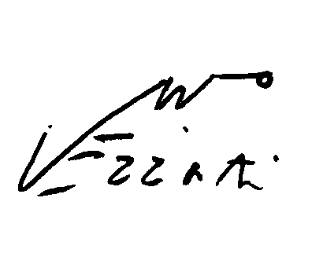
Signature of Candidate……………………………………………….........................................
Signature of Supervisor..................................................................................................................
Notes:
Maximum Word Limit for PhD/EngD Thesis: 100,000 words; MPhil Thesis: 60,000 words; MD(Res) Thesis: 50,000 words. NB The Word Limit includes footnotes, but excludes the bibliography and any appendices. If you believe you have valid reasons for exceeding the word limit please send an email to research.degree@imperial.ac.uk citing the reasons and seeking permission to exceed the limit. Only when you have approval for this should you submit your thesis.

